TOBOGGAN RUN DESIGN
Student Name
Institution
Course Name/Number
Due Date
Instructor Name

DESIGN JUSTIFICATIONS & ASSUMPTIONS
These are the design assumptions relevant to this Toboggan Chute
- Integration with other recreational sports. The project assumes that the regulations, zoning and codes relevant to this Toboggan Chute apply to the recreational sports.
- Site improvements. The project assumes that any design alterations have a negligible effect to the entire recreational center future modifications or plans in under place. Therefore, the design team has the ability to proceed without the need for revising the risk mitigation protocols associated with future expansions until the project is complete.
- Funding. The stand of the design team is that all sources for all contractors and sub-contractors depends on the agreed terms and conditons between the firm and the Ministry of Transport and Infrastructure in Kuwait. Therefore in the event of procurement difficulties the two parties have the right to hear and consider any design and implementation setbacks.
- Master-Plan. This Toboggan Chute relies it design principles from the general vision 2030 plan in Kuwait and therefore it maintains the plans for sustainability and environmental protection by maintaining the stand that all activities should and will comply with the natural environmental site functions. But since these aspects remain of complex nature with the project’s budget constrainsts then some capabilities, depth and scope can come as compromise only if the activities don’t undermine the safety, health and environment of the general public.
- Feasibility Analysis. The goal of this project is to explore the chance of building and actual recreational sports activitiy through the implementation of a Taboggan chute and therefore most tasks have a limitation to theoretical and not practical understanding. Therefore any technical, social or economic aspect that don’t appear in the analysis don’t validate their absence in the real-life case scenario.

DECISION MATRIX
The following technical considerations apply to both the vehicle and chute solutions
Aspect/ Design Requirement | Vehicle solution | Chute solution
Maintainability | Yes | Yes
Sustainability | Yes | Yes
Cost | Yes | Yes
Selectivity | No | Yes
Stability | Yes | No
Interoperability | Yes | No
Ergonomics | Yes | No
Constructability | Yes | Yes
Codes | Yes | Yes
Speed | Yes | No
Reliability | Yes | Yes
Usability | Yes | Yes
Aesthetics | Yes | Yes

DESIGN CALCULATIONS
The first calculation is estimating the impact of both horizontal and vertical inertia forces with respect to passengers in the vehicle. The goal is to construct the force relationship between the people and its impact with through the chute track. Additionally, the same information helps in estimating the brake-lever’s load capacity i.e., the maximum withstanding loads. This scheme quantifies the transmission power of brake levers through a load model that works with freight automobiles. It uses the load applied to pads to develop a diagram that quantifies the operating conditions of brakes that helps in assessing the impact of wear and tear in pads (Ravlyuk, et al, 2019). The end goal is that this measurement establishes the causal relationship with regards to brake pad’s abnormal wear using a calculation algorithm that has effective accuracy with the pad’s pressing forces. These obtained algorithmic equation assesses the wear condition of pads and produced the stress-strain relations that has an effect to the traffic safety of these vehicles.
Another calculation is explaining the rupture process using the dynamic stress parameters. The end-goal is to reconstruct a possible propagating track that changes with rupture time and amount of stress drop for each fault using the kinematic parameters, strength excess between the applied & initial stresses, waveform inversion methods and rupture time. It relies on a model referred to as Barrier and it has the benefit of investigating the dynamic rupture process while including numerical computations using the Monte Carlo technique that has the benefit of being both practical and effective.

SAFETY ANALYSIS
The main safety objective is to ensure that the brake levels of vehicle operate effectively (Piskoty et al., 2007). It means conducting mechanical tests, metallographic and fractographic analysis to determine the possibility of fractures that undermine the overall safety through fatigue of fractures in these vehicles (Piskoty et al., 2007).
The safety simulation using the lumped parameter model also works with the passenger vehicles operating in the Toboggan chute. It involves conducting side-impact safety simulations for the lumped masses and multi-bodies for the side structure systems and energy-based studies through the finite element technique. The goals is to quantify the mass construction of the side-structure sub-system and that of the vehicles for depicting the safety considerations. Such predictions with the dummies in vehicles explain the thoracic trauma index impact for both rear and fron sections that explains the general safety of these passenger vehicles. In a case when there is a good correlation between the occupant response and the structural nature it indicates there is need for a design review with the iteration of the process conducted till the vehicle is fit for use. The method use referred to as Lateral Impact New Car Assessment Program quantifies the lumped masses for explaining the side, front and rear impact in case of accidents.
Other safety considerations in this Toboggan vehicle include; explaining the fatigue life of components through the acceptability of the effective strain damage model or load sequency effect for automotive, quantifying the environmental-assisted crack in the chute using the crystallographic and morphological texture, determining the corrosion damages in the chute, explaining the flooding conditions of Turnout systems, role of station cracks and their stabilization mechanism while laying anchor cables, structure health monitoring of sandwiched structure in the chute through strain-related measurements.

BUILDING PROCESS
SITE CONDITIONS
The first step is to assess the field-site for this Toboggan Chute which includes the technical steps from the Land surveying to estimating the rolling topographies for the streams, wetlands, farm fields and residential houses near the field site. Other steps include; examining the maximum slope elevation, investigating the soil types through Morley-Blount association, site vegetation analysis using the type, size and density parameters.
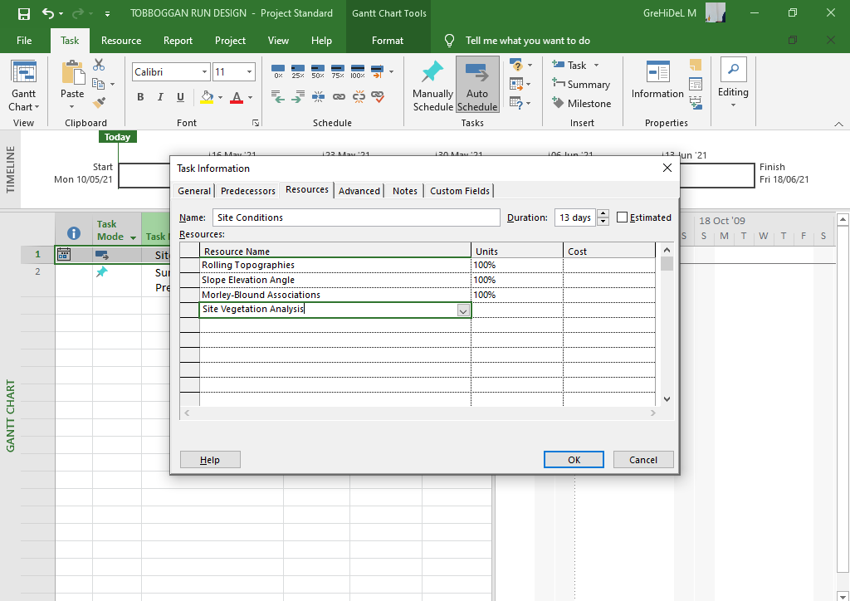
Figure showing the Tasks and Resources for these site conditions.
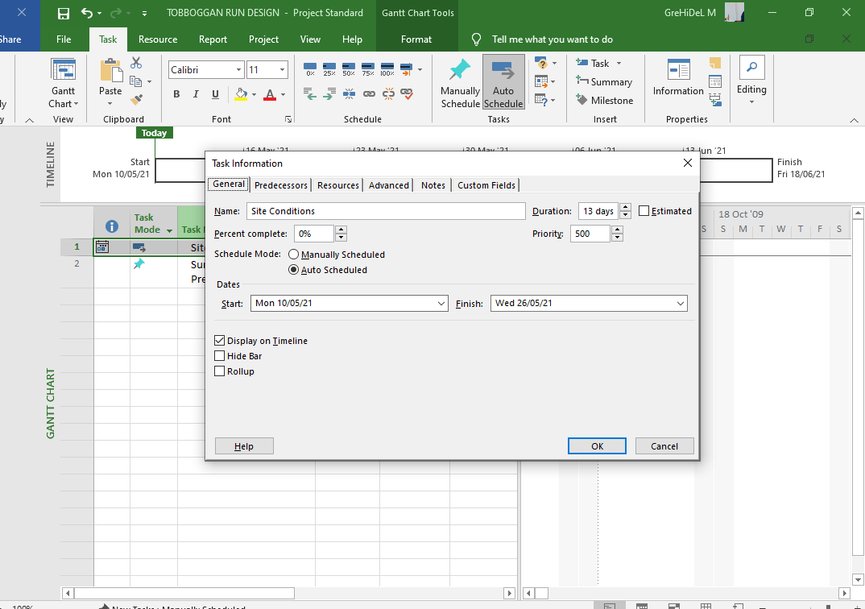
Figure showing the Site condition Task Element from Microsoft Project
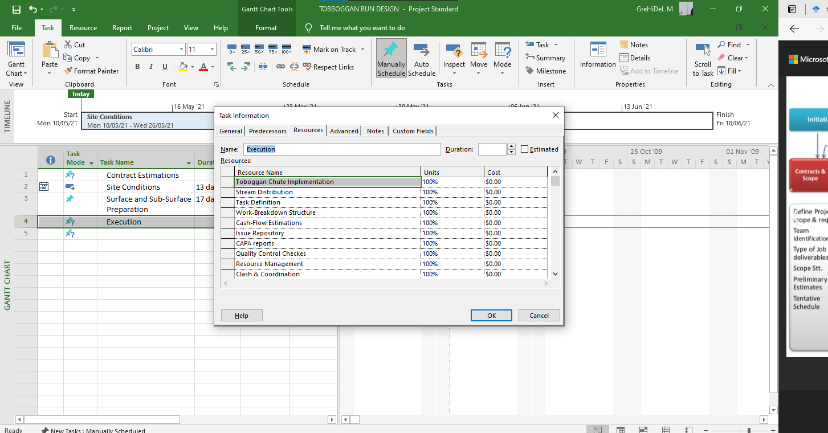
Figure showing the Resource Allocation process from Microsoft Project.

REFERENCES
Piskoty, G., Klotz, U. E., Kovacs, G., Weisse, B., Rütti, T. F., & Stutz, A. (2007). Analysis of a tragic accident on a summer toboggan run. Engineering failure analysis, 14(6), 1083-1092.
Ravlyuk, V., Ravliuk, M., Hrebeniuk, V., & Bondarenko, V. (2019, December). Research of the calculation scheme for the brake lever transmission and construction of the load model for the brake pads of freight cars. In IOP Conference Series: Materials Science and Engineering (Vol. 708, No. 1, p. 012026). IOP Publishing.

